K2

Women are increasingly breaking barriers
March 19, 2017 K2 Leave a comment 143 Views
Women are often expected to stay home, cooking, cleaning and taking care of kids. That’s the traditional belief.
Bhutanese women nowadays are advancing and becoming successful in traditionally men-dominated careers. They are more confident and independent. They are breaking the barriers and challenging the stereotypes.
The country’s first woman gup, Namgay Pelden, is one of the examples of Bhutanese women entering the male-dominated profession. The 34-year-old woman and a mother of two, is currently the gup of Tashiding Gewog in Dagana. This is her second term.
Before becoming a gup, Namgay Pelden joined the education ministry as a Non-Formal Education instructor after completing class X from Bajo Higher Secondary School in Wangdue.
Namgay Pelden said that women in the past did not take part in the political processes or other men-dominated professions because of lack of education and other facilities like access to roads and electricity.
“It was not easy to walk to places to perform your duties and taking care of your family at the same time,” she said.
Today, however, atmosphere has changed. It is convenient for both the men and women to work in any sector anywhere in the country with facilities like road connectivity even in the remotest places in the country, electricity in all the dzongkhags and Internet connection, among others,
Namgay Pelden said that as long as opportunities are provided, there is nothing that women cannot do. Beaming with pride, she quickly added that it was a proud moment for her when she was elected as the first women gup in the country.
Namgay Pelden, along with other newly-elected gups, received dhar and kabney from His Majesty The King in 2011 and again in 2016.
“I was worried how I might be able to set a good example and how I could live up to the expectations of His Majesty The King and the people,” said Namgay Pelden. Initially, she had difficulty coping with her new career and was not sure from where to start and how to carry out her duties.
But she quickly learnt by asking the experienced people around her, including the gewog administrative officer.
“I am now confortable working since I have gained the experience,” said Namgay Pelden.
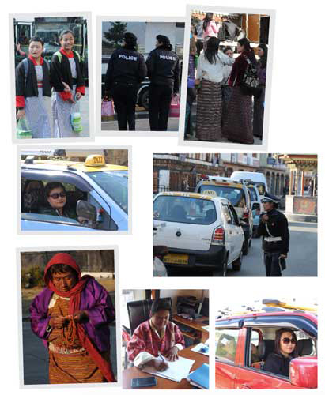
Bhutan has made a lot of progress over the years in the area of gender parity. However, prevailing stereotypes and traditional beliefs continue to affect many aspiring women like thirty-seven-year old Tsheten Zangmo from Dokar in Paro. She is a farmer.
Tsheten Zangmo has been the gewog’s mangmi for five years after she got elected in 2011. She served as geydrung (gewog clerk) and as a Non-Formal Education instructor for four years after class X in 2000.
Tsheten Zangmo contested for the post of gup in September last year but was not elected. She said that in some dzongkhags people still think that only men can and should take up a gup’s position. She puts things quickly into perspective. During Drubchoes in dzongkhags like in Punakha and Wangdue, gups have to perform roles of pazap (warrior), wearing traditional Bhutanese warrior dress, with sword and dance in dzong’s courtyard.
The belief that prevails in certain communities is that women cannot ride horses like pazaps do. It is considered inauspicious. Tsheten Zangmo said that such beliefs restrict women wanting to step into traditionally male-dominated careers.
When she served as a mangmi, she stood in for gup many times. She said the work includes more risks but is more or less the same. She had no problem working as a mangmi. She contested for the gup post in the last election because she believed that she is capable. “Even the people I know encouraged me to contest for the post saying I am capable.”
When she did not get elected, she asked herself and the people close to her what could be the reasons and found that people in her village think that only men can be gups.
The government and authorities concerned are creating gender parity awareness. Yet, there still are people who hold on to the traditional belief that women’s place is only in the kitchen.
Tsheten Zangmo said that there is still a long way to go before we can really change the mindset of the people. During gatherings and meetings, people accept the idea of gender parity and supports women breaking barriers in the male-dominated professions. But, in reality, very few support women.
“More awareness has to be created among the peoplen especially men in the villages to break stereotype that women cannot do this and that,” said Tsheten Zangmo.“I lost the election but I did not fail.”
Tsheten Zangmo said that women should come forward and do what interests them when the government provides the opportunity. “Despite interest, if women don’t come forward saying she is shy or she cannot do it, then there will never be gender parity,” said Tsheten Zangmo. “If we are willing, I think there is nothing women can’t do.”
Albeit slowly, once male-dominated professions like driving, armed forces, auto-mechanics and working in a construction sites are no more restricted to men.
Pema Choki, 37, a mother of three, decided to drive taxi a few years ago to financially support her husband. She earns a minimum of about Nu 1,000 a day. Her husband, who had been undergoing treatment for almost two years, supports her decision to work and encourages her to be independent. Pema Choki said that since driving a car doesn’t require physical strength, it’s something that all women can do.
Nima Zangmo, 27, is a police in the traffic division. She is usually seen monitoring pedestrians at zebra crossings along Norzin Lam in Thimphu. She had special interest to join the law-enforcing agency since very young. She joined the agency after class X in 2013.
Although she did not face any major challenges while serving as a constable, it was not easy undergoing the training. She said that there are some women who do better than men at training.
“I think it all depends on personal interest. I like what I am doing and I will continue to work hard.” She said.
These women are examples of how women are slowing but surely breaking the stereotypes in the society.
Dechen Tshomo

